Time Complexity & Big-O notation
_________________________________________________________________

Q. What is time complexity?
_________________________________________________________
Time complexity is mathematical function which always takes some input and generates some result
In terms of time complexity this function accept input as processor operation

Q. Why we need to understand the time complexity of code?
__________________________________________________________________
1. With the help of time complexity we can understand better code.
2. Now days top product base company asks you what time complexity of code is.

Q. Pre-requisite knowledge for time complexity?
________________________________________________________________
1. Basic coding knowledge
2. Need to understand the mathematical function
3. Known about the resource utilization

Q. What is resource?
________________________________________________________________
Resources is part of system which is responsible decide the execution and working of system called as resources.

There are two types of resources
__________________________________________________________
1. RAM
2. Processor

If we think about time complexity we required to know the process utilization

Example: Suppose consider we have two developer names A and B and we give problem statement XYZ to developer A and B means we give same problem statement to both developer and both developer provide solution to us suppose consider developer A solution execution in 3 sec and developer B solution execute in 5 sec here we consider developer A give better solution
But the challenge is if suppose Developer A has modern machine and Developer b has old style machine so there is possibility developer A solution may be not better take less time because of machine configuration and Developer B solution may be better but take more time because of machine configuration
So we cannot judge performance application based on execution time of program so if we want to solve this problem we need to identity the process operation required in developer A solution and Developer B solution

Means we can say if we want to calculate the time complexity of any problem statement we need to know the process operation of the application or need to calculate the processor operation in application.

How to calculate the process operation
__________________________________________________________________
If we want to calculate the processor operation you have to standardize it.
Rules for calculate processor in code
1. Every Assignment operator in application consider as 1 individual processor operation
2. Every Arithmetic operation in application consider as 1 individual processor operation like as + , -, *, / etc
3. Every Comparison operator like as <,> , <=, >= etc consider as 1 individual processor operation
4. Every return statement consider as 1 individual processor operation

Q. Why processor operation calculation is important when we want to calculate time complexity?
Processor operator System independent operation.

Now we want to discuss about the one example
_________________________________________________________________
suppose consider we have one example
solution 1:
int addMul(int m)
{ m = m+1;
return m*5;
}
if we want to calculate the processor operation of above code we can calculate like as
m = m + 1 here + consider 1 operation , = consider as 1 processor operation means m = m+1 container two process operation 1+ 1
Again we have statement return m*5 here return required 1 processor operation and * multiplication required 1 process operation means we can say return m*5 contain two processor operation so m=m+1 and return m*5 required total 4 processor operation

Suppose consider some one write code like as
solution B –
int addMul(int m)
{ return (m+1)*5;
}
if we think about above code we have statement return m+1*5 here return required 1 process operation , m+1 required 1 process operation and * multiplication required 1 processor operation so here we required 3 processor operation so when we compare both code then we can say solution B is better than A
Note: if we think about both code in terms bigo notation we get same time complexity O(1) but we will discuss big o notation later in this chapter.

Now we want to discuss about one more example for calculating process operation
int sum=0;
for(int i=1; i<=n; i++)
{ sum = sum+i;
}
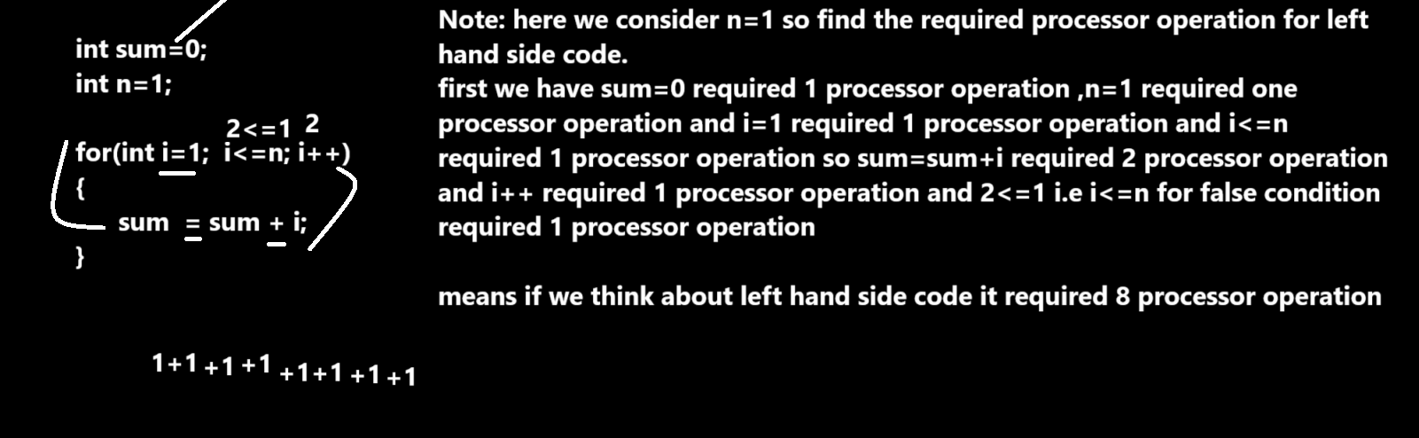

if we think about generalize terms for processor operation then you get result like as
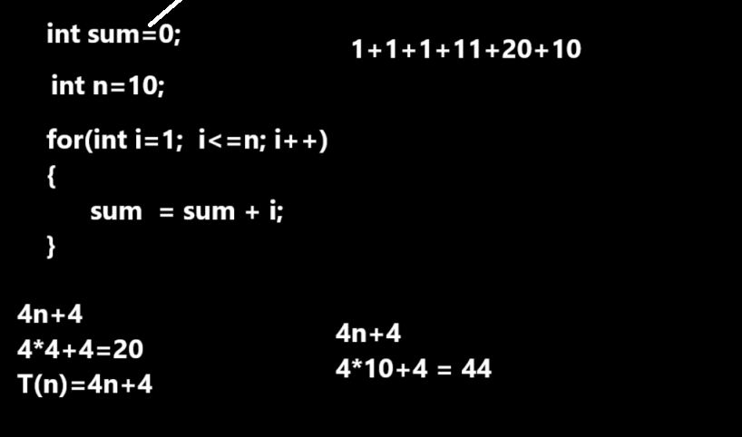
Now we want to discuss about two algorithms for comparison
1. Linear search
2. Binary search

Suppose consider we have following values in array and we want to search data in array
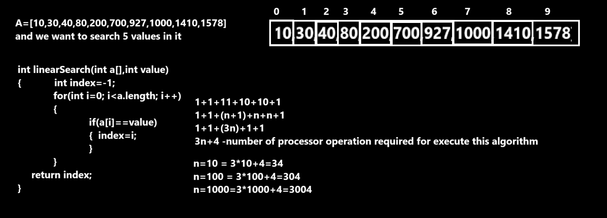

Above screen shot display the processor operation for linear search algorithm

Now we want to perform binary search operation
__________________________________________________________________
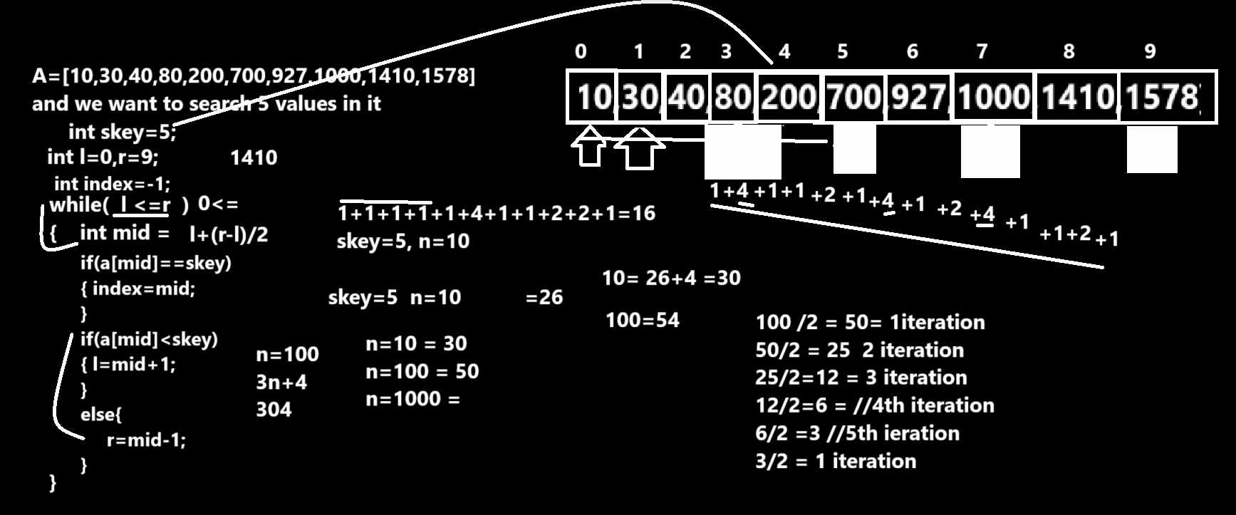

Q. What is time complexity?
Time complexity is mathematical function which takes some input and generates some output
If we think about this function in programming terms then input size is our input and processor operation is our output
So basically time complexity is denoted by T and input is denoted by n
so it represent like as t(n) if we think about previous mention input we can calculate processor but now we want to calculate this processor using mathematical functions or terms

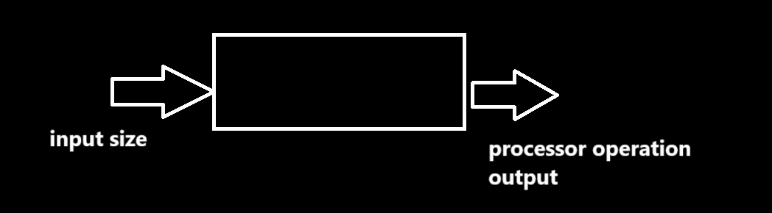

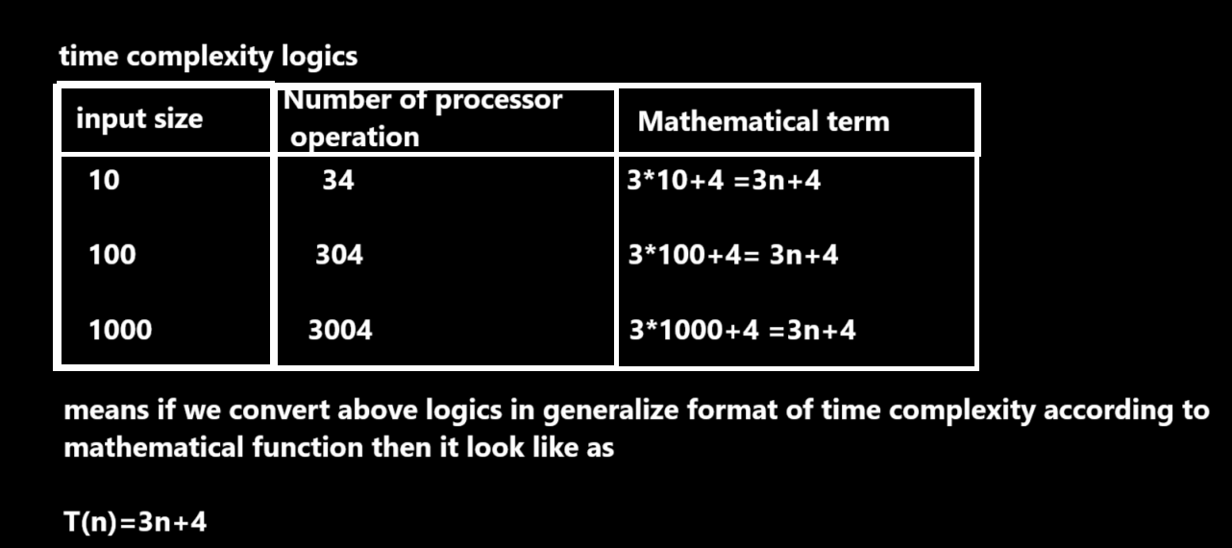

Now we want to discuss the Big O(notation) in time complexity
___________________________________________________________
Big O notation is unit for major time complexity and if we think about Big O notations then just consider the large value input or big values or big number of processor operation and big o notation remove the constant values and smalle values in function just consider large value

Example:
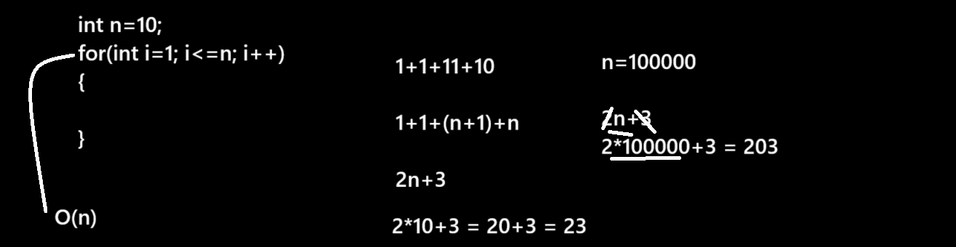
Note: if we think about above code we get time complexity O(n)
Remove the small and constant values.
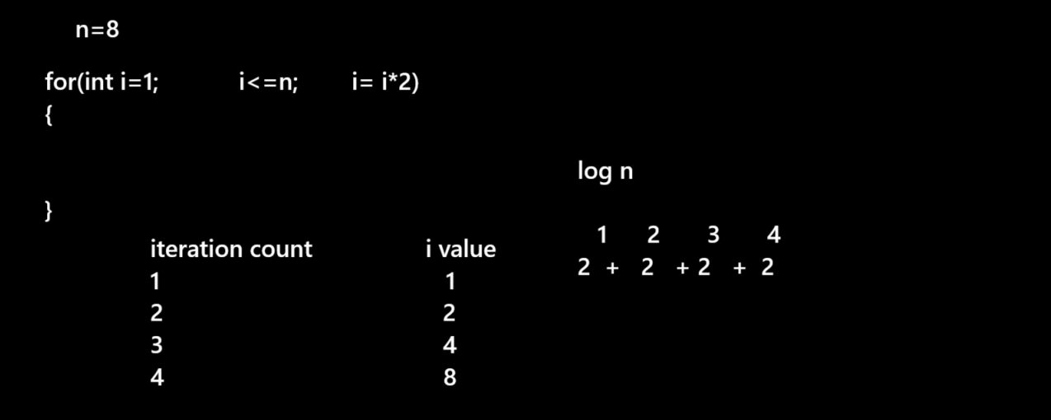
If we think about above code we get time complexity O(log n )
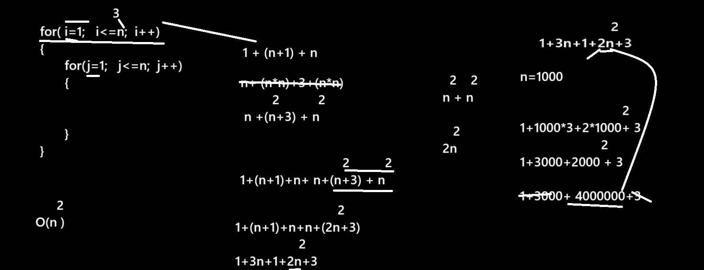
if we think about above code the time complexity of above code is
2
O(n)
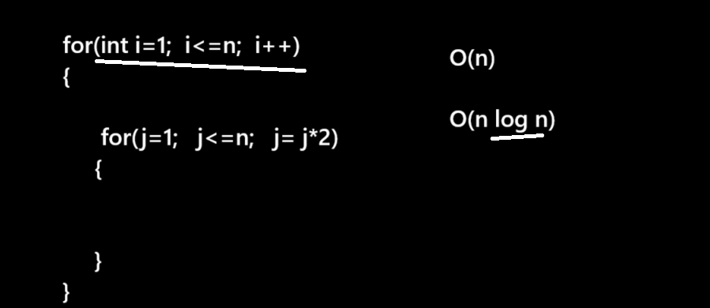

Time complexities -
O(1)
O(n)
O(log n)
2
O(n)
O(n log n)
